Project 2

Individual Assignment Term 2 (Group 10)

Uzair Rabin 221013245

**ERD Diagram**

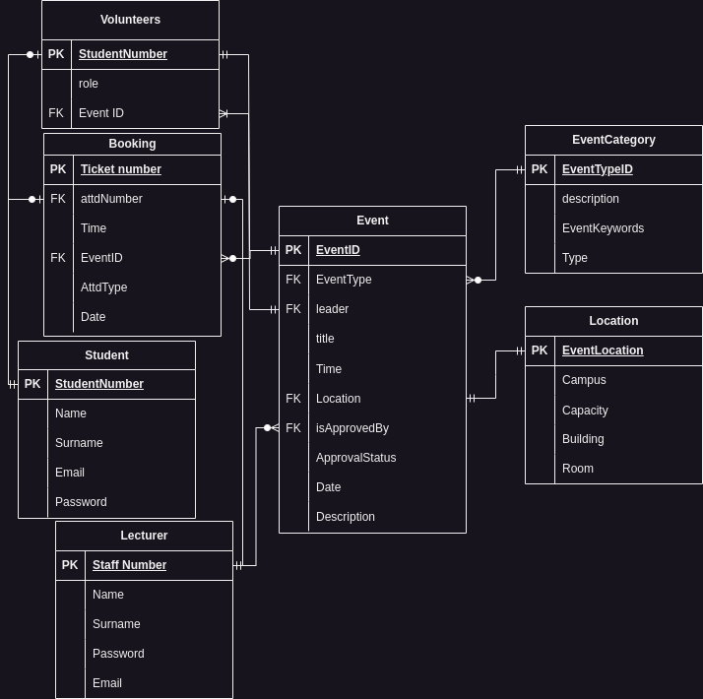

**Description of table, types of attributes and sample data**

**Event Category Table**

The Event Category table consists of an attribute called EventTypeID, which is also a primary key of this particular table and a foreign key of the Event table in the ERD diagram. This table will also determine which category a specific event falls under. The event category table has a one to many relationship to the event table as an event can only have one category type but many events can have the same category type.

|  |  |  |  |
| --- | --- | --- | --- |
| **EventTypeID** | **Description** | **EventKeywords** | **Type** |
| HJ398BN2 | An event including all education activities | Motivation | Educational |
| KLM12V44 | An event including all sport activities | Rugby | Sport |
| GB678AS3 | An event including all Arts & Culture activities | Sing | Art & Culture |
| MA33HJV9 | An event including all social activities | Board games | Social |
| ZOK1094B | An event including all Agriculture activities | Food | Agriculture |
| HJ398BN2 | An event including all education activities | Career | Educational |
| KLM12V44 | An event including all sport activities | Soccer | Sport |
| HJ398BN2 | An event including all education activities | Lectures | Educational |
| GB678AS3 | An event including all Arts & Culture activities | Painting | Art & Culture |
| KLM12V44 | An event including all sport activities | Obstacles | Sport |

**Event Table**

The Events table is responsible for storing all the necessary information of an event created

**ATTRIBUTES**

* **EventID:** Events unique identifier
* **EventType:** specifies the category of events
* **EventLeader:** Creator or Host of event
* **Title:** The name of the event
* **Description:** A detailed portrayal of the event
* **Time/Date:** Day of the event, duration of the event (Start – end time)
* **Location:** Where event will be held
* **ApprovedBy:** The status of event approved or denied by lecture
* **ApprovalStatus:** Status of event (Approved/Denied)

|  |  |  |  |  |  |  |  |  |  |
| --- | --- | --- | --- | --- | --- | --- | --- | --- | --- |
| **Event_ID** | **EventType** | **EventLeader** | **Title** | **Description** | **Time** | **Location** | **Approved_by** | **Approval_status** | **Date** |
| KFB38YH4 | Education | 56289524 | IT fundamentals | Guidelines given to inexperienced students on what IT is about. | 13:00:00 | CPTHAL | 78329067 | FALSE | 18/07/23 |
| MAK401GY | Sports | 22789451 | Soccer | Soccer friendly match. | 09:00:00 | BSPSOB | 12893455 | FALSE | 22/09/23 |
| LAGH409T | Arts & Culture | 65900523 | Sing off | Students compete to determine best singer | 09:00:00 | LEC119 | 22894509 | TRUE | 09/11/23 |
| AGH356D5 | Education | 87234450 | Multimedia Design | Motivational speaking | 15:00:00 | BELHAL | 89896572 | TRUE | 29/11/23 |
| S7H2M9HY | Arts & Culture | 81139457 | Artistic Wall of Fame | Students can display their artwork | 11:00:00 | CPTHAL | 78449013 | TRUE | 28/06/23 |
| GH66I4BT | Sports | 81452009 | Rugby | Rugby match. Winner receives cash prize | 09:00:00 | BSPRUB | 22064998 | FALSE | 13/08/23 |
| W3H60W18 | Sports | 66338914 | Soccer | 5 team tournament. | 14:00:00 | BSPSOA | 56009152 | TRUE | 15/10/23 |
| ZO209CV1 | Education | 12305728 | Software development Guidelines | Development practices given to students to better their programming | 15:30:00 | BELHAL | 89356287 | FALSE | 27/07/23 |
| LA78B6FS | Social | 39013879 | Fun day | Students can participate in any fun activities available | 08:00:00 | LEC119 | 33894560 | TRUE | 17/11/23 |
| 67BITH49 | Arts & Culture | 99285001 | Creating Your Own Way | Motivational speaking | 12:00:00 | CPTHAL | 11945035 | TRUE | 25/08/23 |

**UI Design**

**Students Events Page**

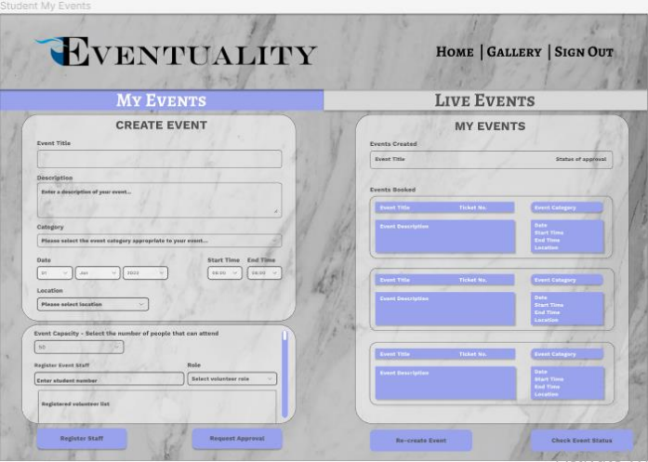

**Event Category Table**

The event category table is implemented when the student creating an event (on the left side of the page) must select a category type from a drop down list. The list will be populated with records from the event category table such as Agriculture, Art & Culture, Educational, Sport and Social.

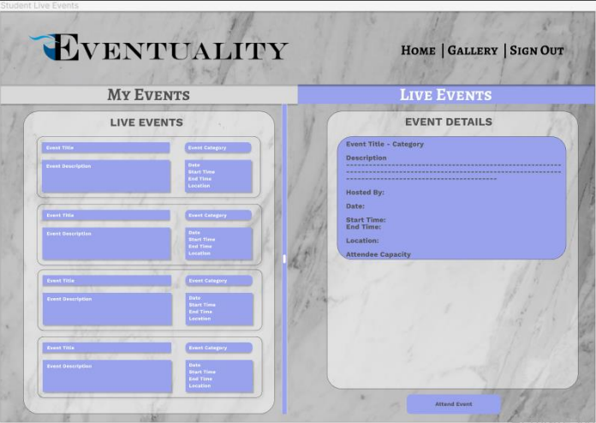

**Event Table**

On the left side of the picture above we can see the Event table being implemented where it displays the necessary information relating to the table.

Coming back to the Event Category table, once the event which was created by the student has been successfully approved, the event category will be displayed in the event details (on the right side of the above picture) for those attending.

**Business Rules**

* New users must register.
* They can only register if they have a student/staff number.
* A student can become a volunteer.
* An event can have multiple volunteers.
* A student can be a volunteer for multiple events.
* A student can be the leader to one active event at a time.
* A Student/Lecturer can book attendance to a live/approved event.
* An event can have multiple bookings.
* A Student/Lecturer can only book one ticket to an event.
* They can book to multiple events.
* A lecturer can approve or deny multiple events.
* If event is denied, student can create a new event.
* A student can edit the event if it’s pending.
* They cannot edit if it’s approved.
* An event can only be one type, many events can have the same type.
* An event must be held at a location.
* Only one location can have an event at a time.
* Students/Lecturer can request password change if forgotten.
* Students are not charged for booking.
* Booking must be made 7 days before event occurs.

**Reflection**

As a team undertaking this project, we have made excellent progress. We had quite a few challenges along the way such as having to change our ERD diagram to meet specific requirements and produce the correct outputs that are needed.

Thus far, we have also completed our wire-frames which were thoroughly designed using UI/UX design laws as well as having to decide on color schemes, fonts, layouts etc. This accommodates the users by allowing them to have a user friendly interface whereby they are able to interact and carry out their actions.

Having completed most of our design work, we are now able to take this project to greater heights and begin with the execution phase.